TOBI build

These are instructions for building version 3 of TOBI. All necessary files can be found [here](https://drive.google.com/drive/u/2/folders/0BwheKCTAIzZKdWx3ZVVINFZ2eVk) . The Solidworks copies of all the parts are included if you want to make any edits, or just the STL and DWG files if you want to make it as is.

**Soldering Tips**

* Always make sure to “tin the tip” by placing a little bit of solder on it before use and before putting the soldering iron away.
* “Whistle while you work” to avoid breathing in soldering fumes.
* Never create “bridges” between pins while soldering. In other words, do not let the solder of one pin connect to the solder of another pin. If this occurs you will need to desolder.
* ALWAYS wash your hands after handling solder.

**PCB Tips4**

* Find the orientation of the PCB by looking at the direction that the text is printed on it.
* The PCB should have outlines on it that match the parts that are supposed to go in each position.
* Trim any excess wire sticking out from the bottom of the board by using wire cutters.

**Day 1- Assembling the Board**

*The associated activities are listed in order*

Morning

1. Resistors (PCB) - soldering
   1. To bend the resistor wires, either use pliers to bend the wire close to the resistor or use the edge of a table to get a nice clean bend (PICTURE).
   2. Try to make sure that all of your resistors are facing the same way when you attach them to the circuit board. This convention makes it easier to check that all of the resistors are the same in more complicated circuits.
   3. Once you insert one resistor, cut most of the wire before you solder.
   4. Look at the picture below to see how the solder on each pin should look. Note that the solder on one pin is not connected to the solder on the neighboring pins. One you are done soldering, cut the excess wire.
   5. Be sure to check that you have 18 resistors soldered to the board.

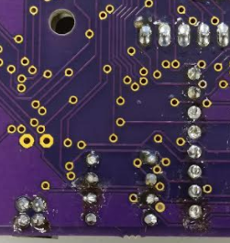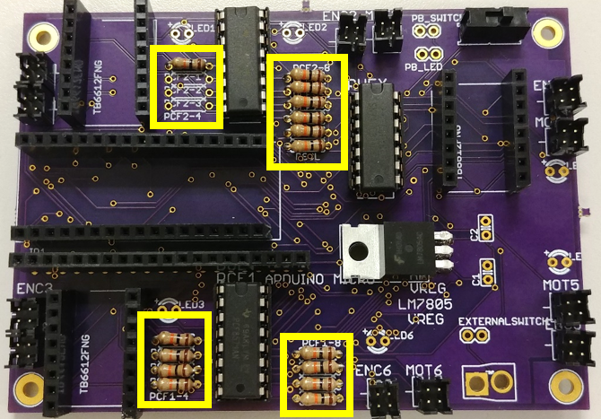

Afternoon

1. Motor Head Plugs (PCB) - soldering (PICTURE)
   1. Line up the side with the unique indentation with the line on the PCB.
   2. Use tape to secure the Motor Head Plugs in place. You may also want to apply gentle pressure to keep the Motor Head Plugs in place as you solder them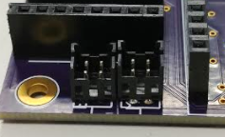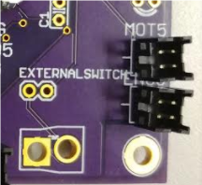
2. Headers (PCB) - soldering
   1. “Headers” includes a variety of pieces that stick up from the board. When soldering headers, start with the headers lowest to the board and work up towards the tallest headers.
   2. The smallest headers on this PCB have numbers on one side of them. Make sure that the numbers are facing towards the top of the PCB. Eventually, you will be attaching a piece on top of it that will fit into it, called a hex inverter. Make sure that the divot on the top of the hex inverter is on the same side as the number.

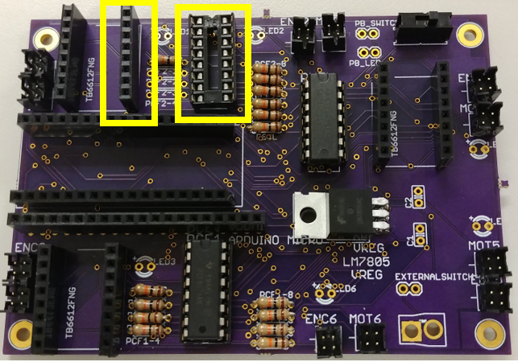

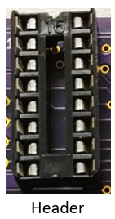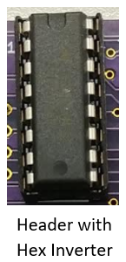

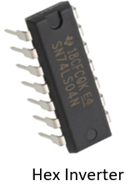

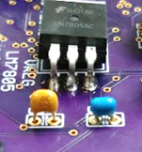

1. Capacitors (PCB) C1 = “104” yellow and C2 = “334K” blue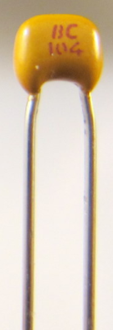
   1. The PCB should have the spots labelled for each capacitor. Make sure that you solder the correct capacitor into the correct place.

**Day 2- Assembling the Board (cont.)**

*The associated activities are listed in order*

Morning

1. LEDs
   1. Check to make sure that your LEDs are oriented the correct way. The longer lead represents the positive end, and should be threaded through the hole on the PCB marked (+)
   2. DEBUG NOTE: If you are missing a resistor (from above), the LEDs will not turn on when the Arduino is powered.

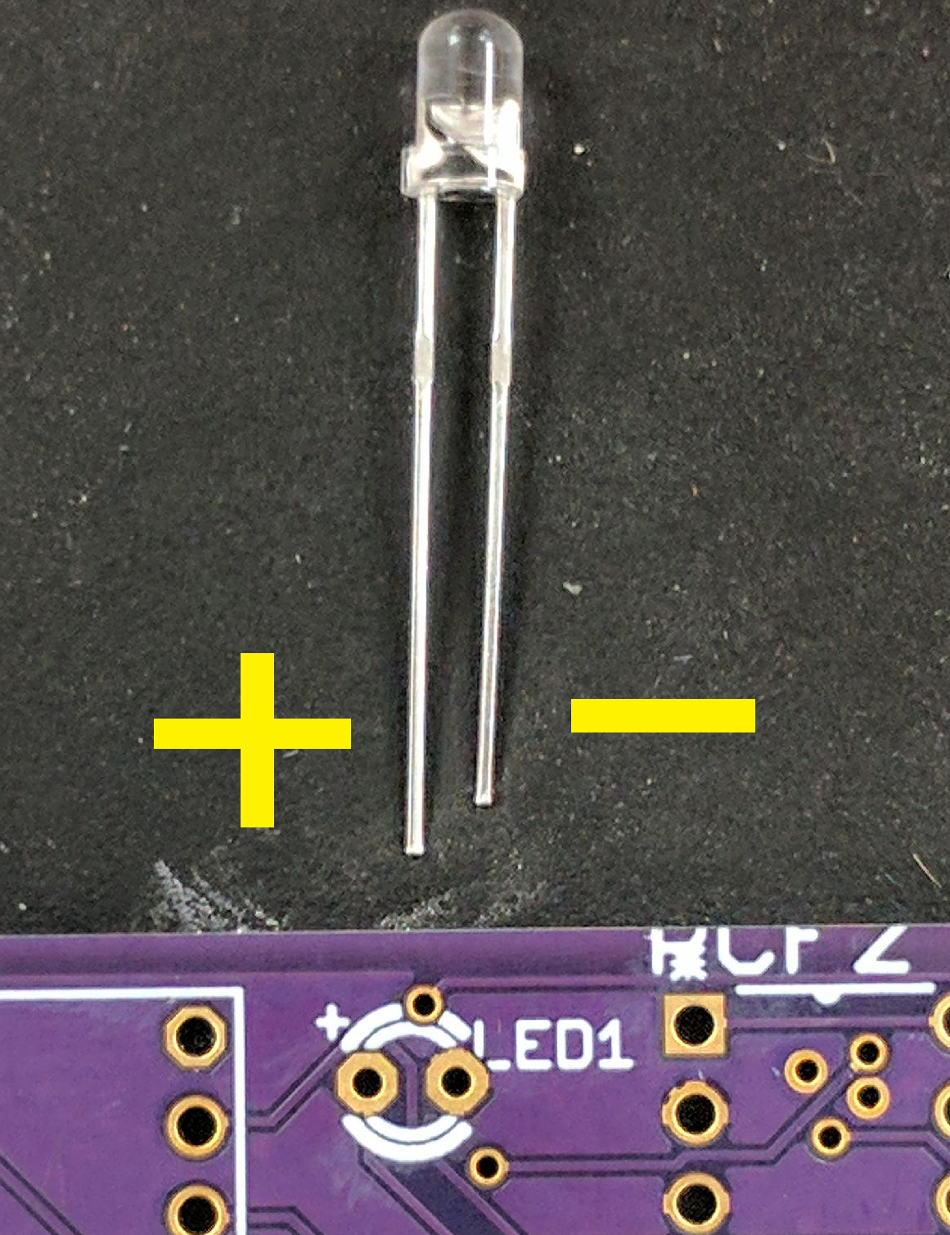

1. Voltage Regulator (PCB) - soldering

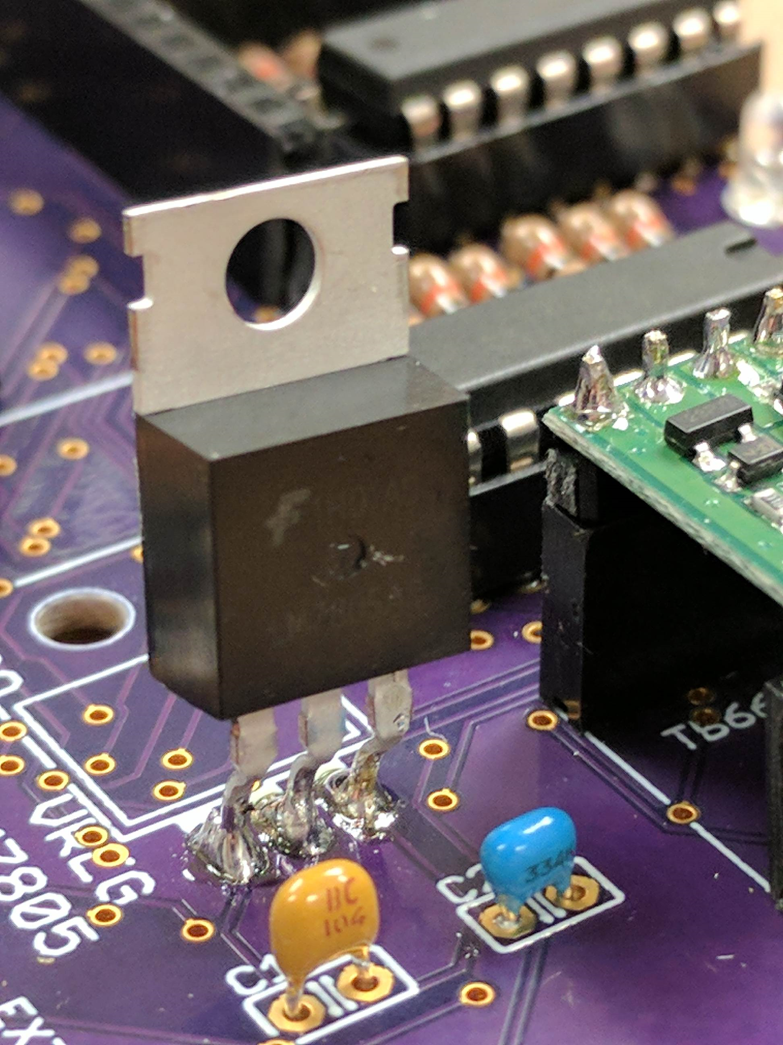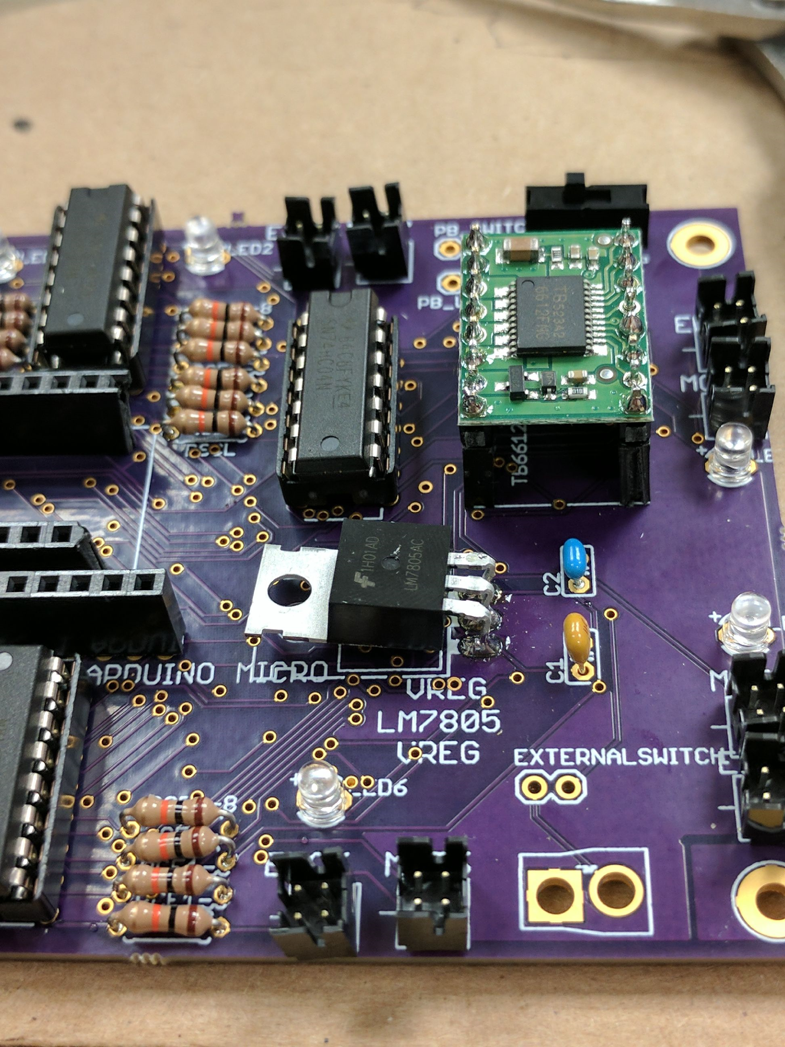

* 1. White part faces outline on the PCB; Try to line up hole in regulator with hole in PCB
  2. Line the Voltage Regulator up with the PCB so that the black box is above the outline of the box on the PCB.
  3. Adjust the prongs so that there is enough room to comfortably reach in with needlenose pliers.
  4. Solder the top connection points to keep the voltage regulator in place.
  5. Solder the bottom connection points. Trim the excess wire.
  6. Use needlenose pliers to bend the voltage regulator so that the hole in the metal is over the hole in the PCB board.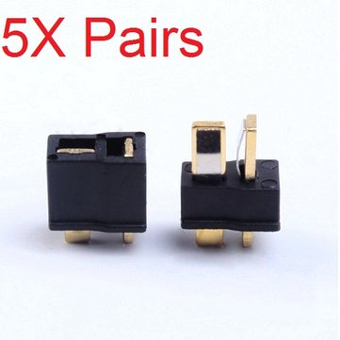

1. Power Connectors (T connector) - soldering
   1. Make sure that the orientation of your T connector matches the orientation outlined on the PCB board.
2. Switch - soldering
   1. The orientation does not matter, so long as the switch is attached to the same side of the PCB as everything else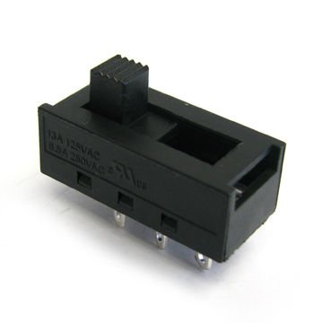

Afternoon

6. Arduino - turning on LED (testing). Plug Arduino into computer and upload a BLINK program to verify the Arduino is working.

7. Expander Board - soldering

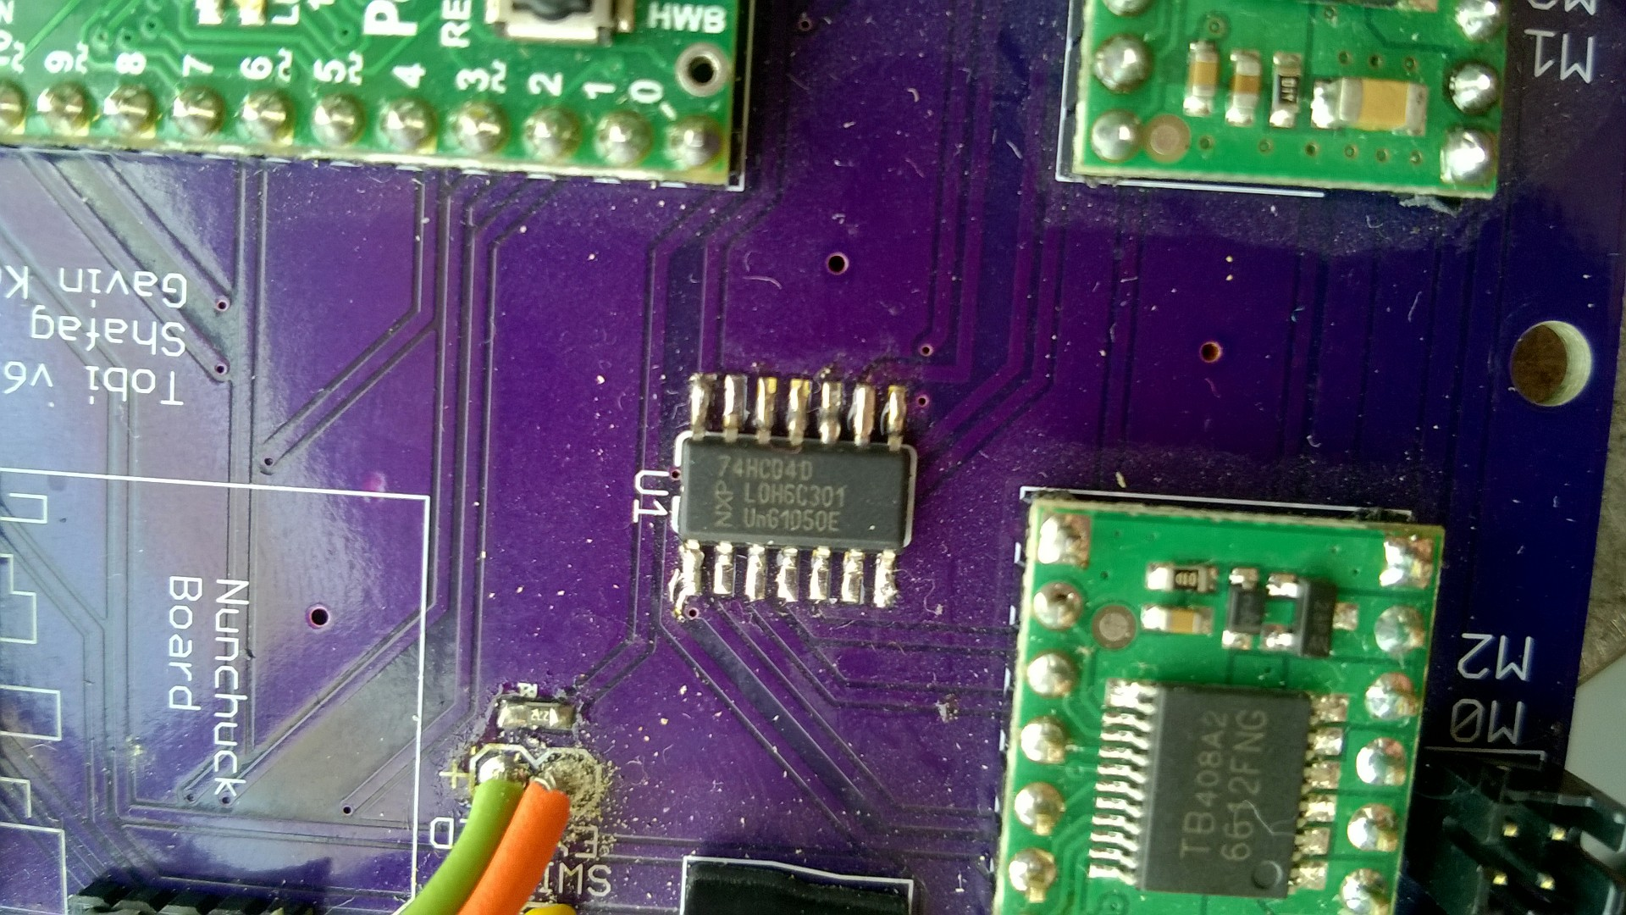

9. Motor Driver - soldering

b. Square holes are for ground - line up grounds with grounds to solder

**Day 3**

*TOBI wrap up session; All Connections*

Morning

1. **Motors - Connectors** (crimped wire, DF11 connectors)
   1. Screw the PCB into the TOBI frame using the 4-40x3/8” screw and the 4/40 hex nut and 5/16” flat washer.
   2. Measure the length of the wires from each motor driver header to its respective motor.
   3. Each motor and encoder pair is labeled with “MOT#” / “ENC#” numbered from 1-6. The motors will be referenced by the software from 0-5. Where “MOT1” maps to motor 0 in the code.
   4. Cut the wires as measured.
   5. Solder one end of the motor wires to the motor leads
   6. Crimp the other ends of the wire
   7. Plug the crimped ends of the wire into socket. When connecting the crimped wires to the socket, the orientation of the wires with respect to the board are important! Follow the convention below of pins/sockets left to right, top to bottom 1-2-3-4 as shown below. For the motors, the motor leads go into sockets #1 and #3.

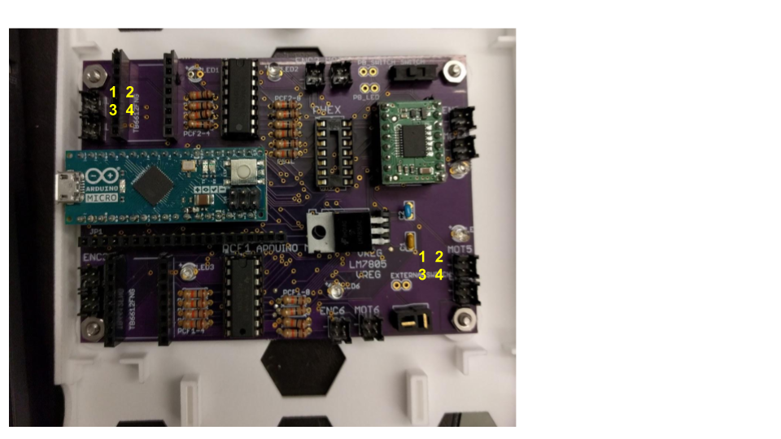

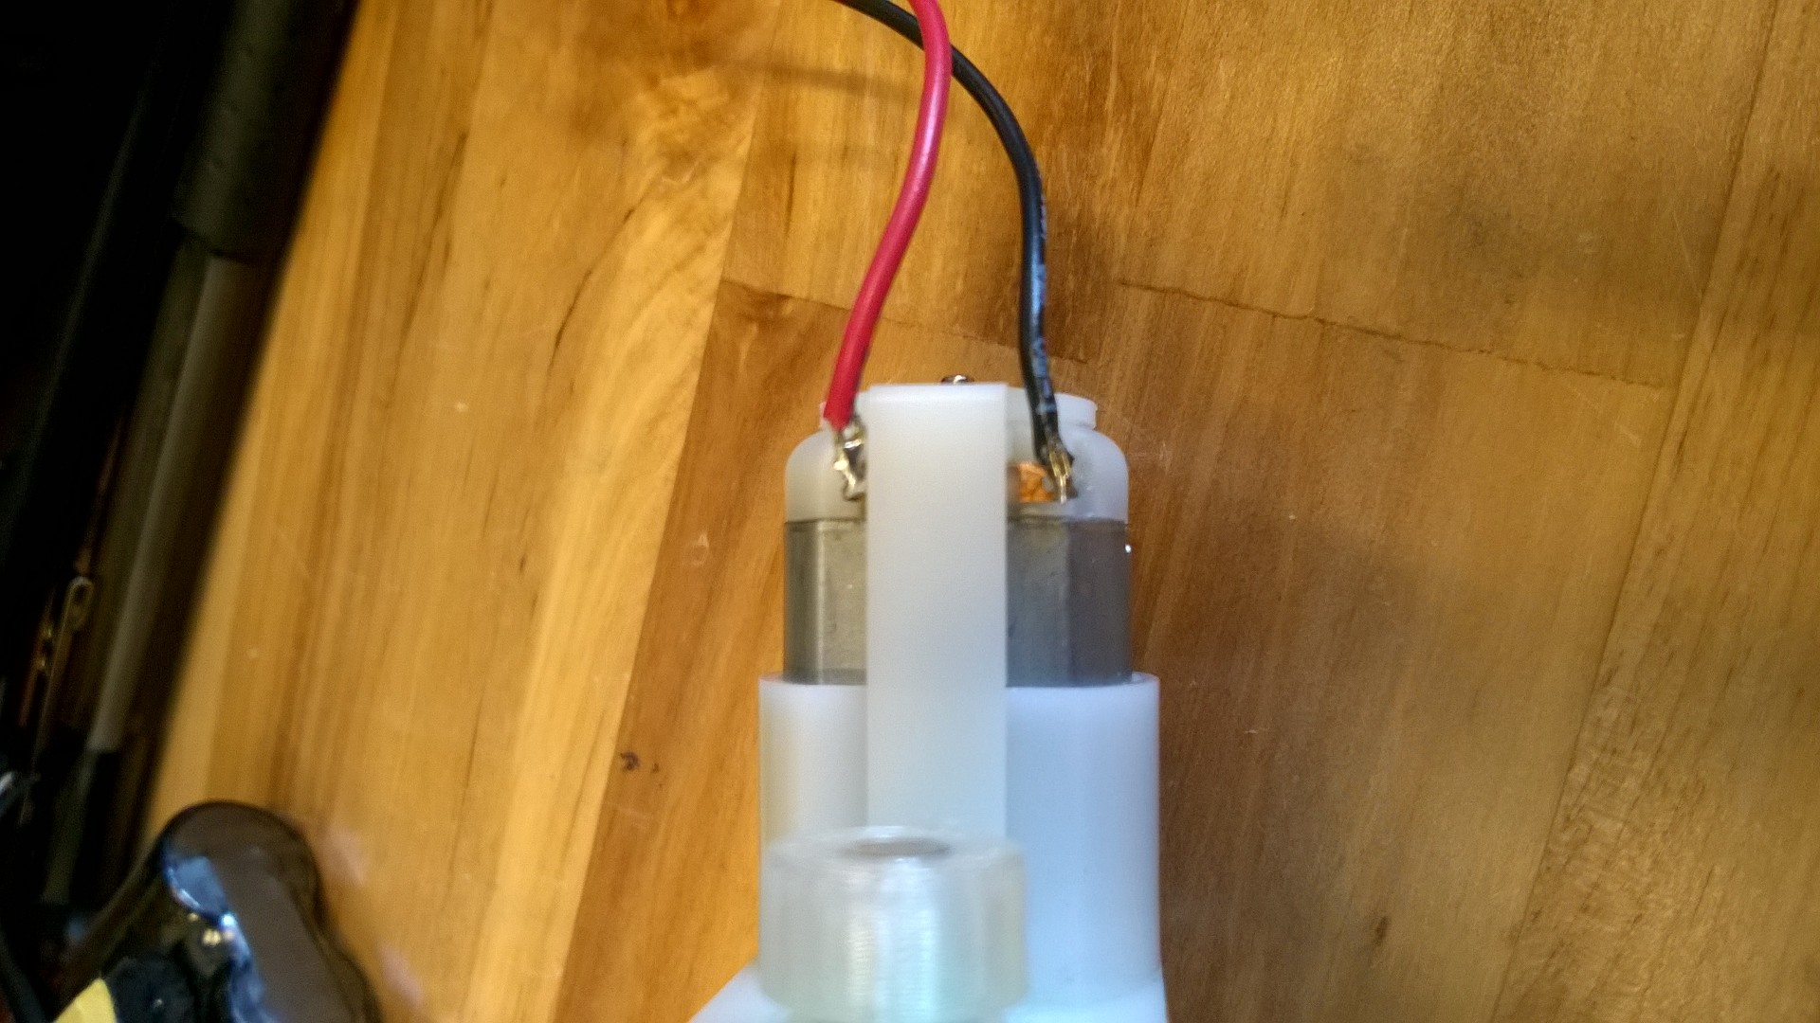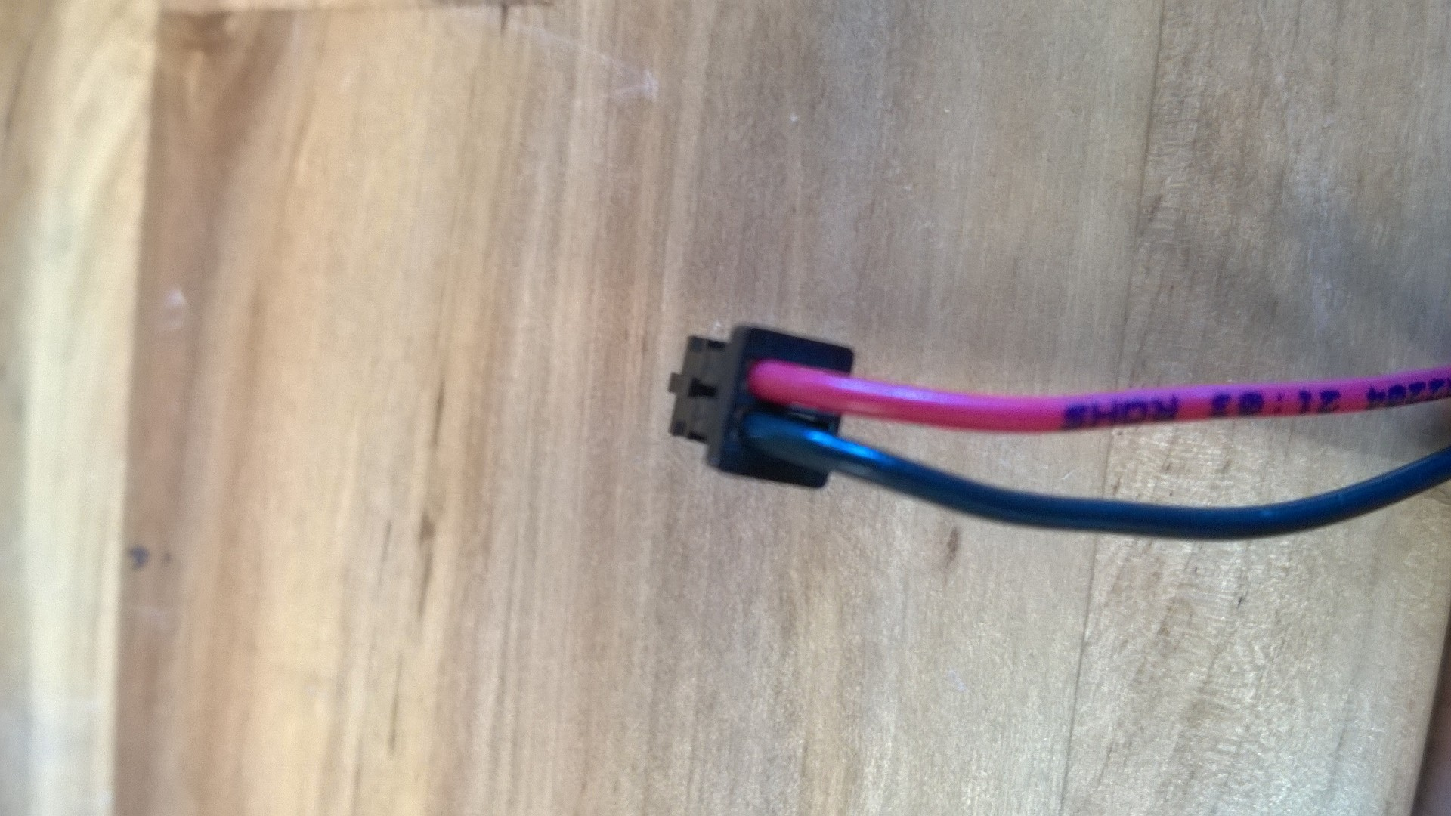

1. **Encoder Boards** (Attach to the breakout board)
   1. Encoder orientation based on white circle in the upper left corner (circle lines up) Use solder paste and a hot plate or hot air.
   2. Measure the wire length similar to the motor wires.

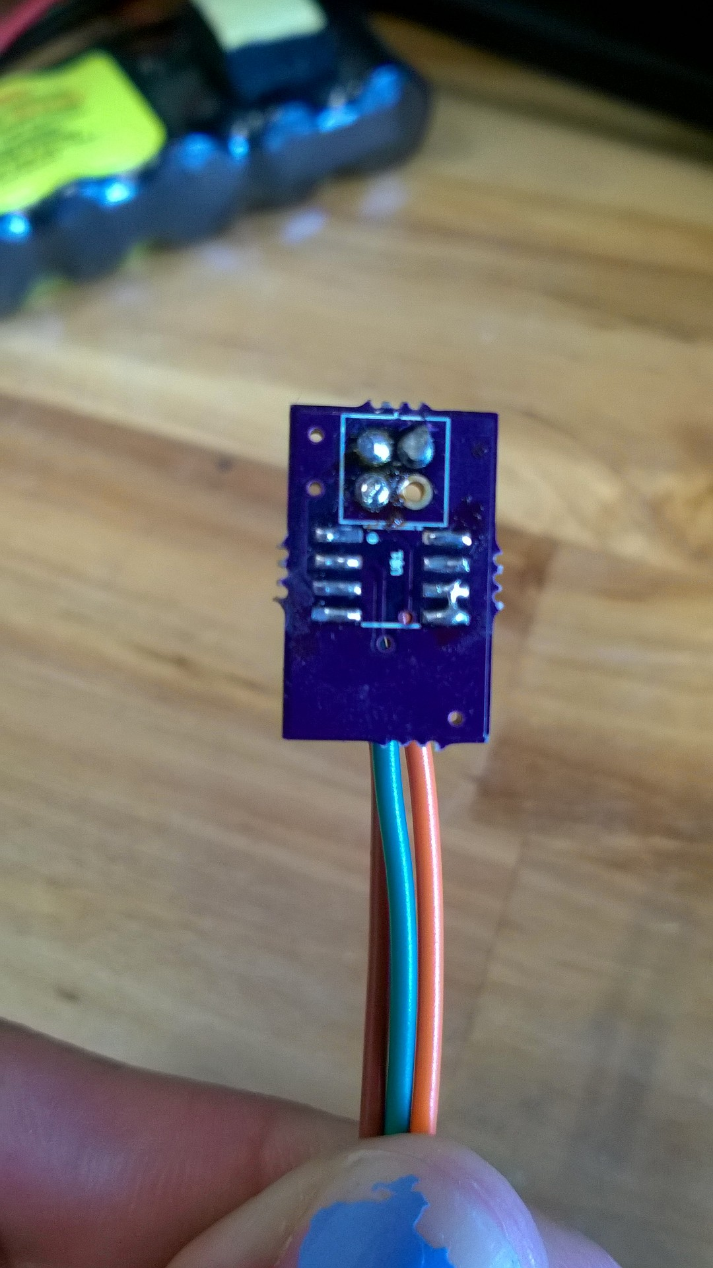 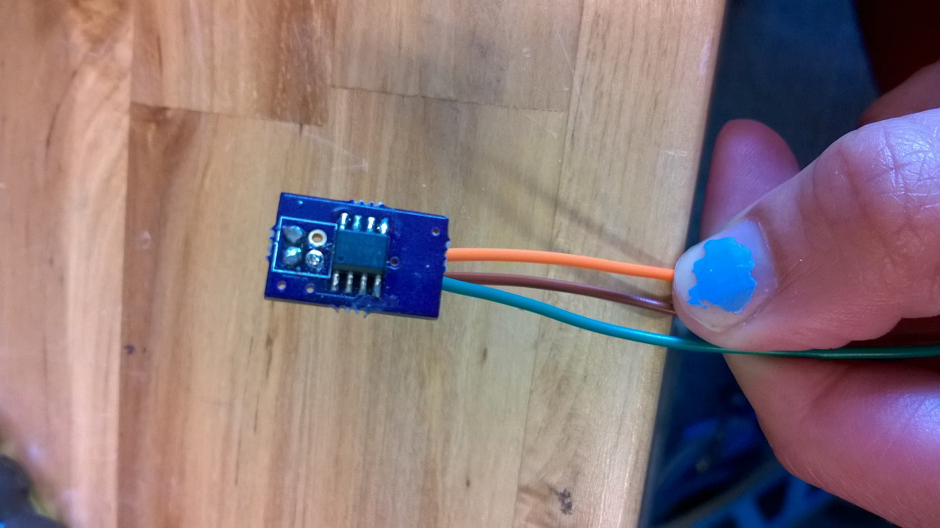

c. Solder 3 wires into back of encoder.

d. Cut the wires in half and solder the non-crimped end to the board

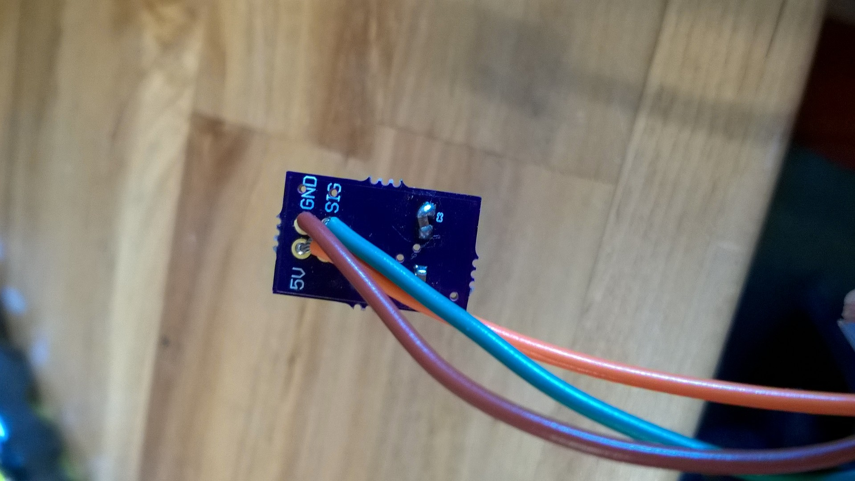

e. Crimp the other ends of the wires.

f. Put the crimped end into the df11 pin connector. Plug in the power in the upper right corner, ground in upper left, and signal in lower left.

g. On the side of the headers, place the ground pin into socket hole #1, the power pin into socket #3, and the signal pin into socket #4 as shown in the below diagram of the header orientation.



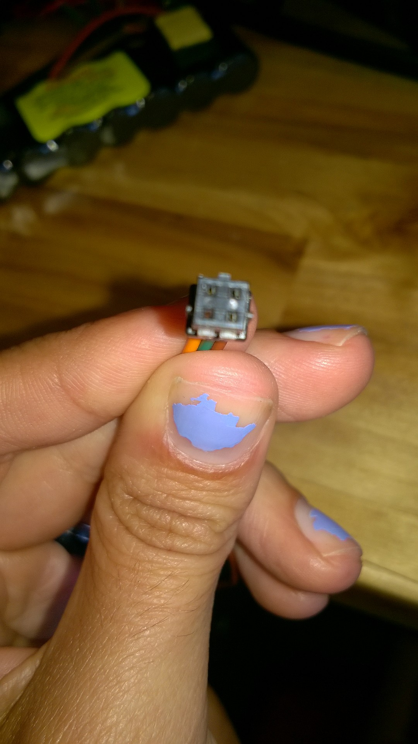 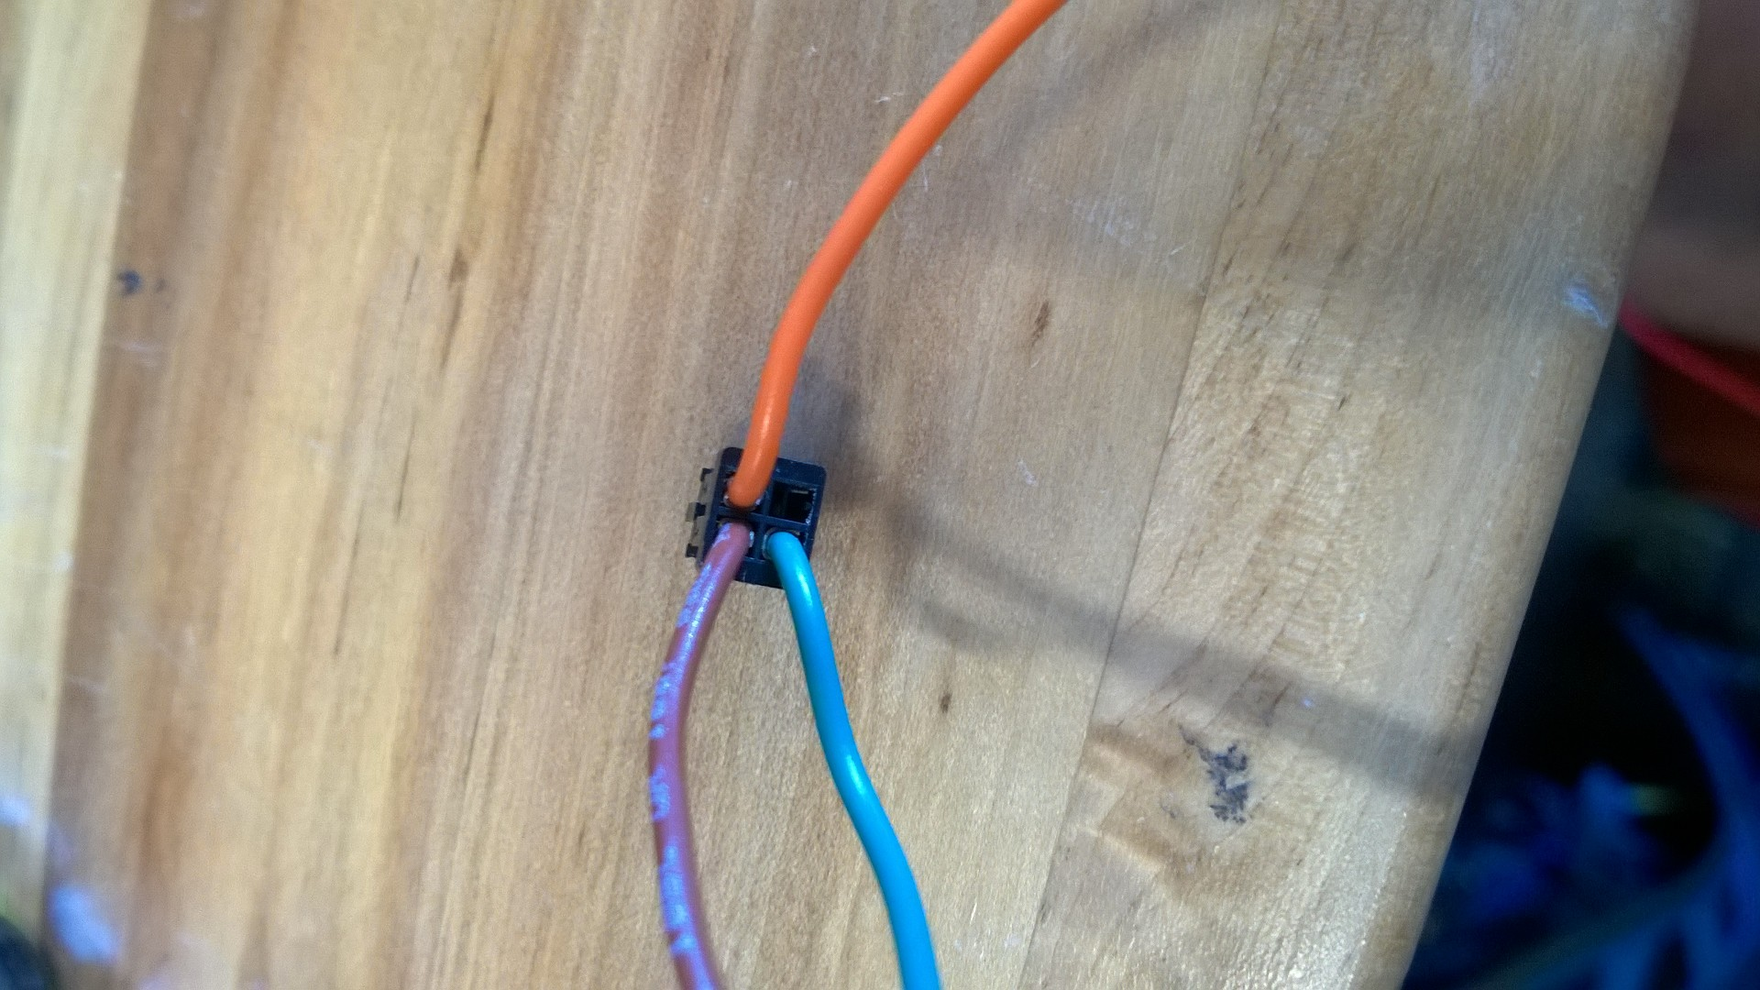

1. **Battery pack** (if not attached, solder the wire with red for power and black for ground). BE VERY CAREFUL WHEN SOLDERING. SOLDERING ONE WIRE AT A TIME AND HEAT SHRINK BEFORE SOLDERING THE OTHER WIRE TO PREVENT SHORT CIRCUITS.
   * 1. Solder the female T-connectors with the red wire going to fatter end. Look at the T-connector like a “T” - the top should be red (power) and the ground (black) wire connects to the downstroke of the T. Think “ground goes down”.

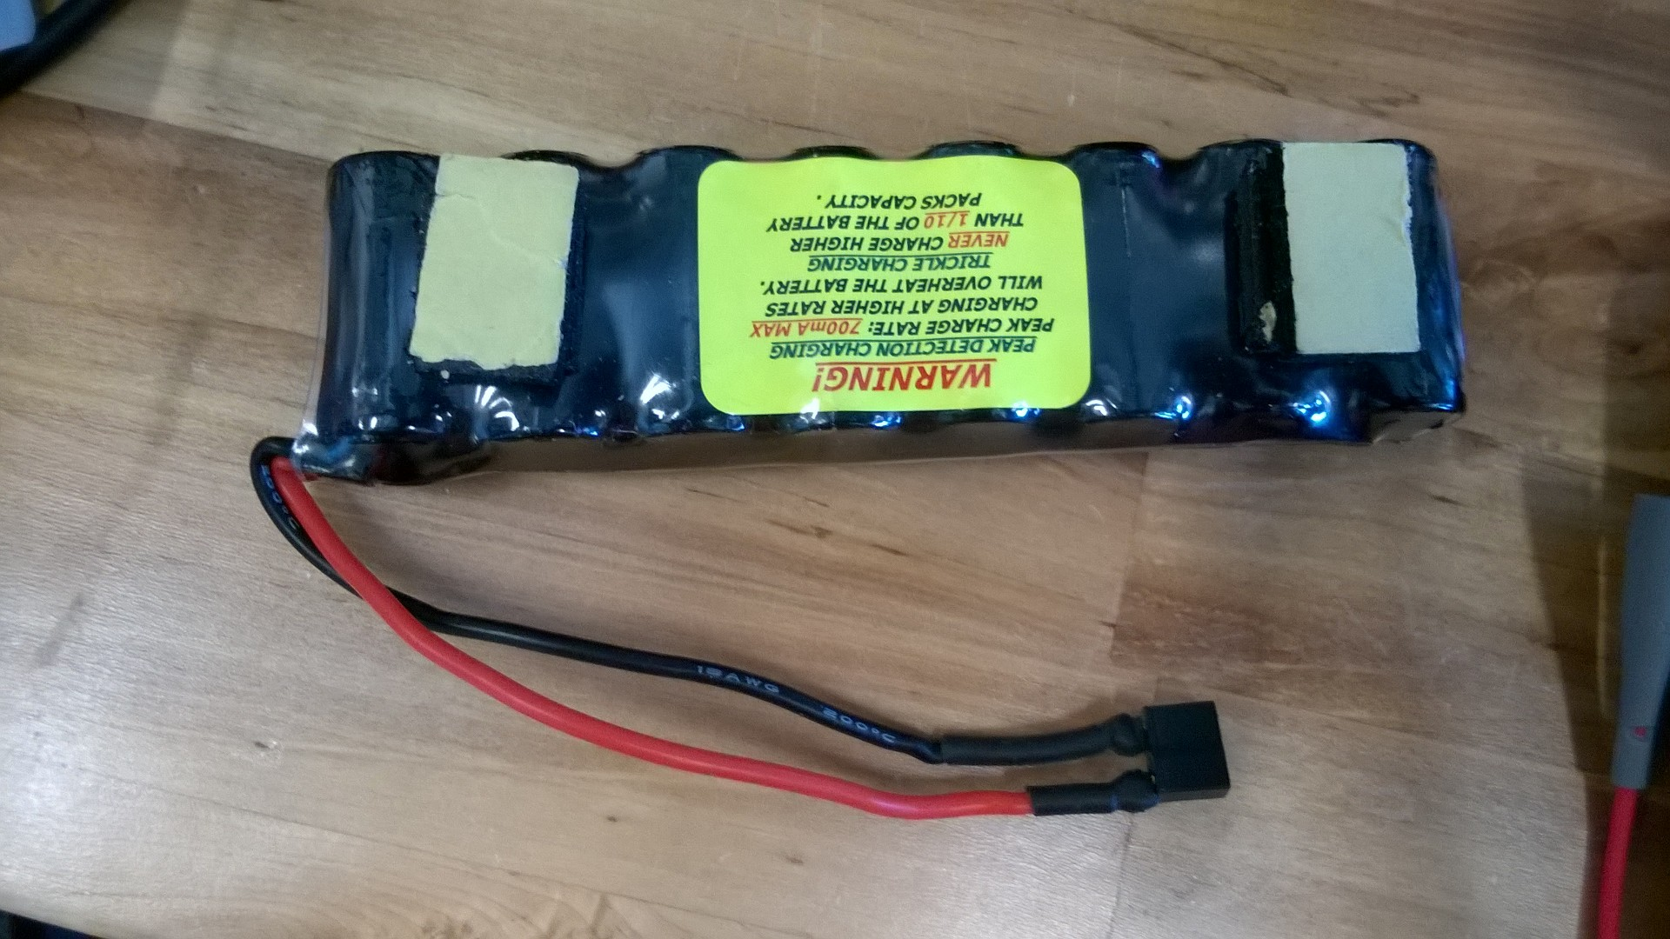

* 1. Charging cable: take 2 red and 2 black wires (long and short). Refer to the diagram below showing the final power connector.

*Long end (female connector) is used to recharge the battery. The short end connects to male connector on the PCB.*

* + 1. Solder the red and a black to a female T-connectors.
    2. Four unsoldered ends, pair red with red and black with black.
    3. Solder to male T-connectors.

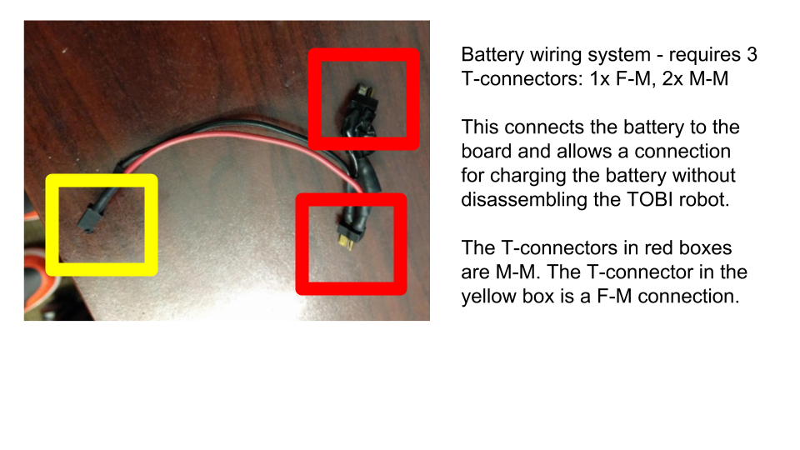

For reference, the 2 types of T-connectors are shown below.

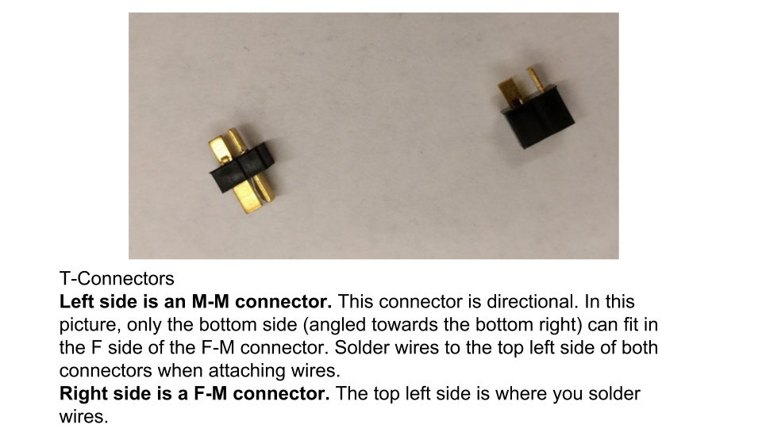

Lastly, to solder the wires together, refer to the tips below for connecting 2 wires.

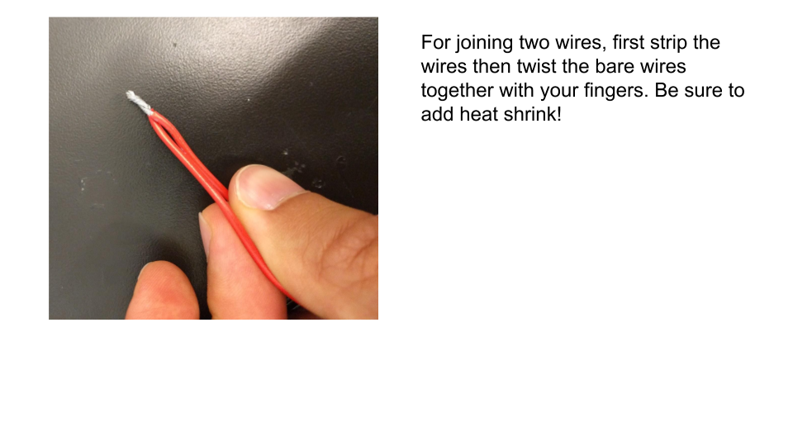

**4. Push Button**

1. To connect the pushbutton, you will need 4 multicore (22 gauge) wires (they can be different colors to help you differentiate). Solder the wires into your board like so:

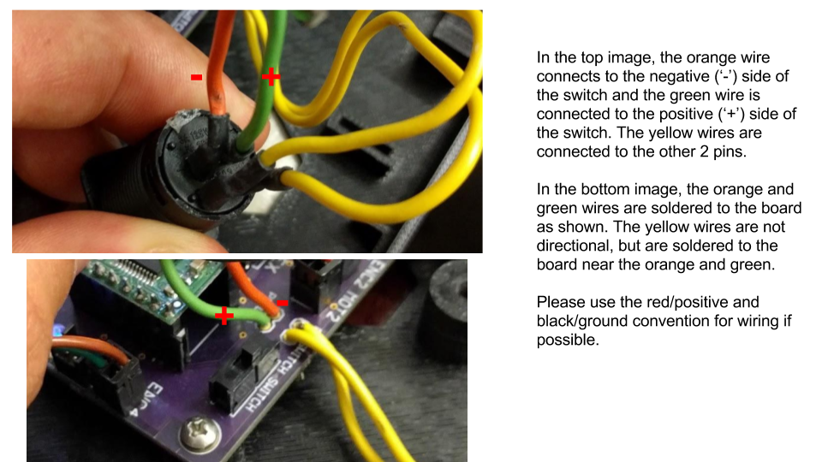

* + 1. The labeling/position of the PB_SWITCH and PB_LED holes are slightly different on this board, but the SWITCH is on top. Then solder the other end of the wire as shown above and use heat shrink.
    2. The button is seated in the half circle opening on the short side of the frame closest to the PCB.

**5. External Switch**

1. The external switch is hot glued to the opposite end of the frame as the push button in a rectangular slot. The length of the wires should be able to reach the “EXTERNAL SWITCH” through holes on the PCB next to the power T-connection.
   * 1. Follow instructions in the diagram below. Only 2 wires are needed for the switch. One wire MUST be connected to the middle pin of the switch. The other wire can be connected to either of the side pins. 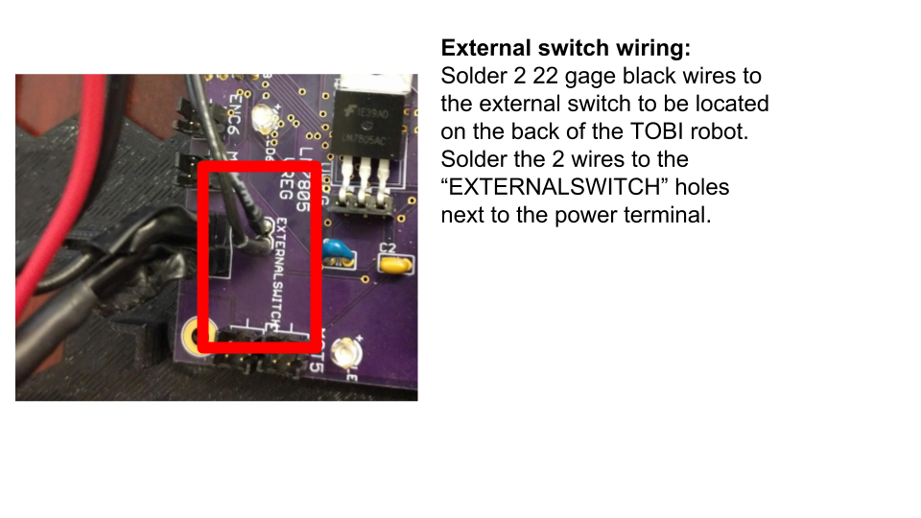
2. **Assemble TOBI**
3. Orient PCB and screw into place with two smaller screws
   1. Arduino should be faced towards opening (holes lined up)
4. Orient battery pack in the front PCB slot
   1. Put the wire from the battery on the side going towards the PCB
5. Charging cable
   1. Hot glue long end in the back slot
   2. Plug the short end into board
   3. Plug the male end into the battery’s cable
6. Add the motors and encoders (same directions for encoders)
   1. Put one motor in each of the slots
   2. Plug the DF11 sleeve into the connector (with the appropriate leg)
7. Placement of top cover
   1. Place breadboard on top of the wires and put top cover over it.
   2. Line up the bottom and top holes; use the long screws to close
8. Add legs and roll bar (make sure they rotate in proper direction).

+++++++++++++++++++++++++++++++++++++++

OLD Directions

1. 3-D Printing
   1. Top and bottom of the case for TOBI (top_edit.STL and bottom_edit.STL in the google drive)
      1. Depending on the size of your 3-D printer, it may say that it is too large and ask you to scale it to size. Do NOT do this, simply leave it as it is and print it with the outer part down on the board.
      2. Once it is fully printed, remove it from the printer and use a pair of pliers to remove excess plastic from the through holes. For the bottom, you will then press fit a DIN985 nut into each hole
   2. Leg and wheel hubs and leg spacer (leg hub_t.STL, wheel hub.STL, and leg_spacer.STL)
      1. You will want to print 4 hubs for each of the motors. You will also need 4 spacers if you are using the legs. Similarly to the top and bottom, you will want to clear out the excess plastic.
      2. For the t_hub, you will then press fit the same size nut as before into the side without the shape. (Pictured below)

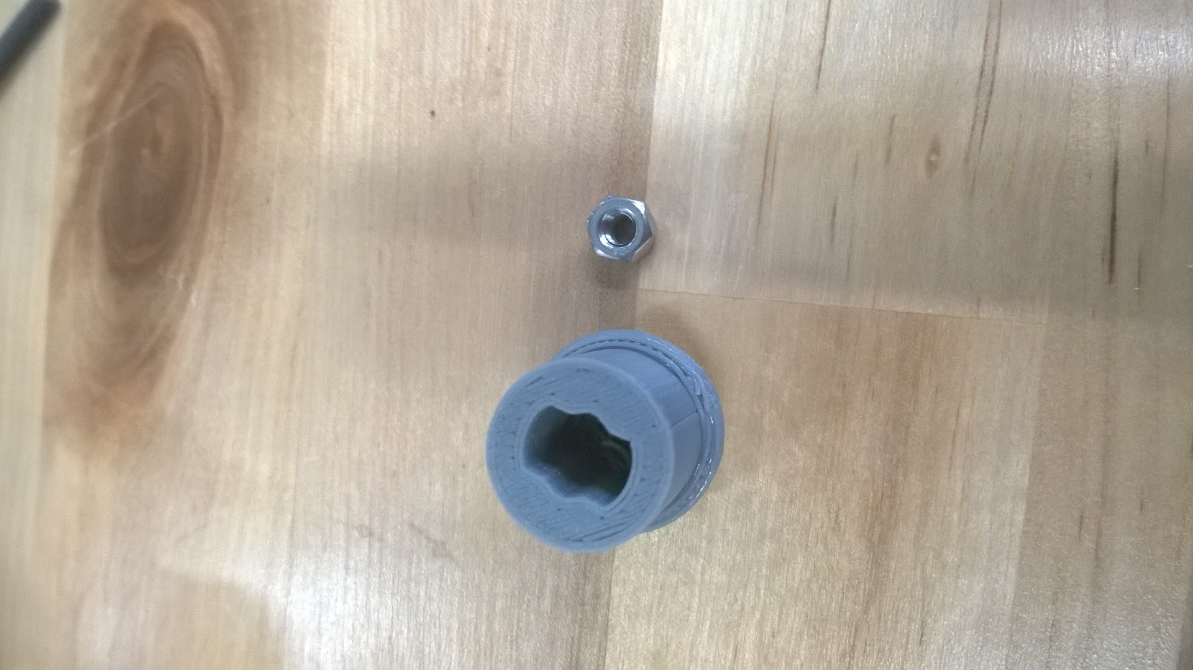 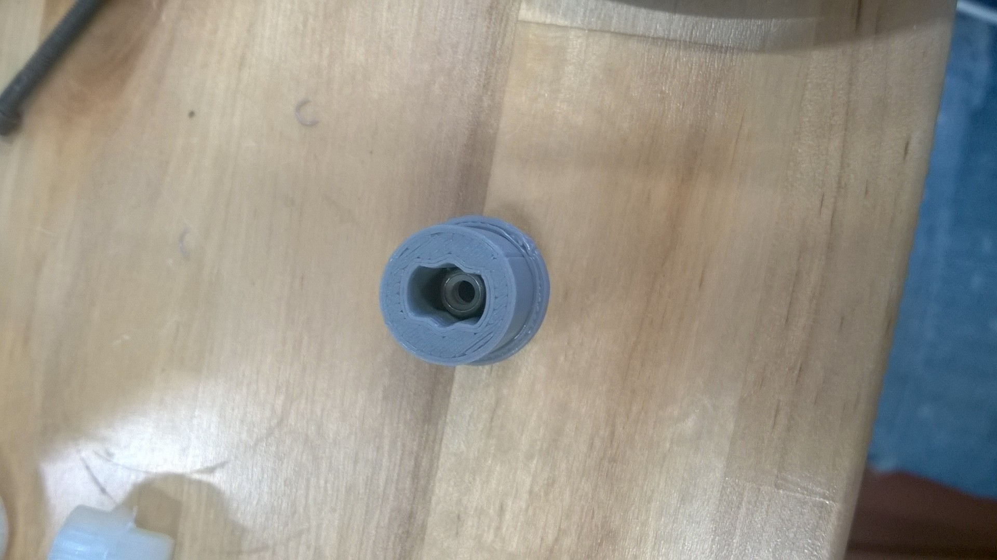

* + 1. For the wheel hub, you will simply super glue the wheel to the hub. (Pictured below)
  1. Magnet holder (MagHolder.STL)
     1. After printing this, glue one end to the inner hub of the motor (Pictured below) and then glue the magnet onto the other side of the holder. This will work with the encoder.

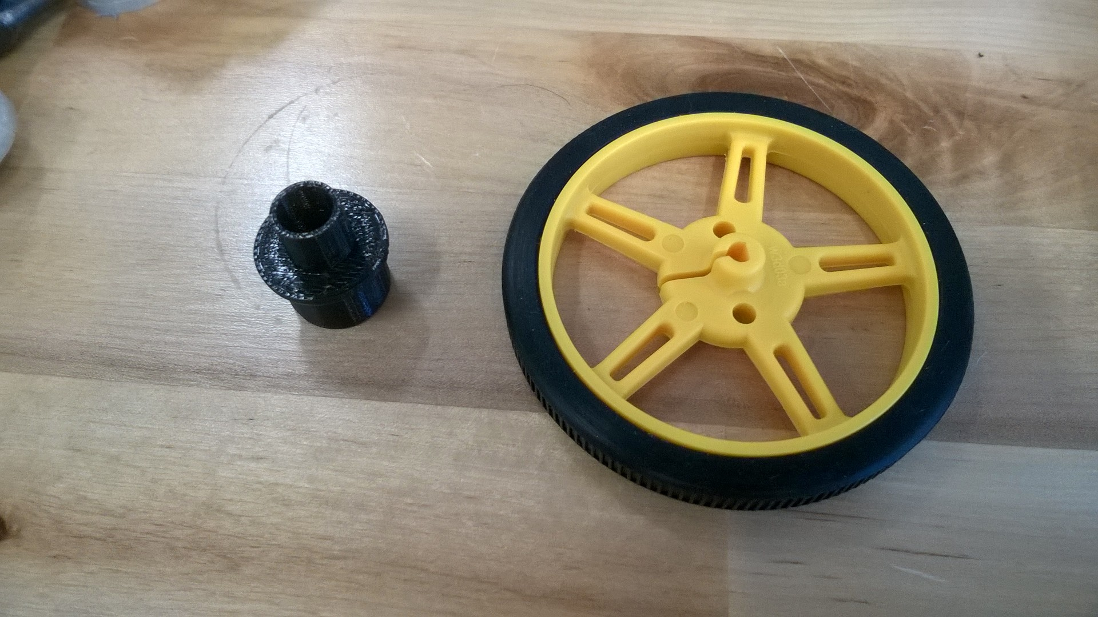 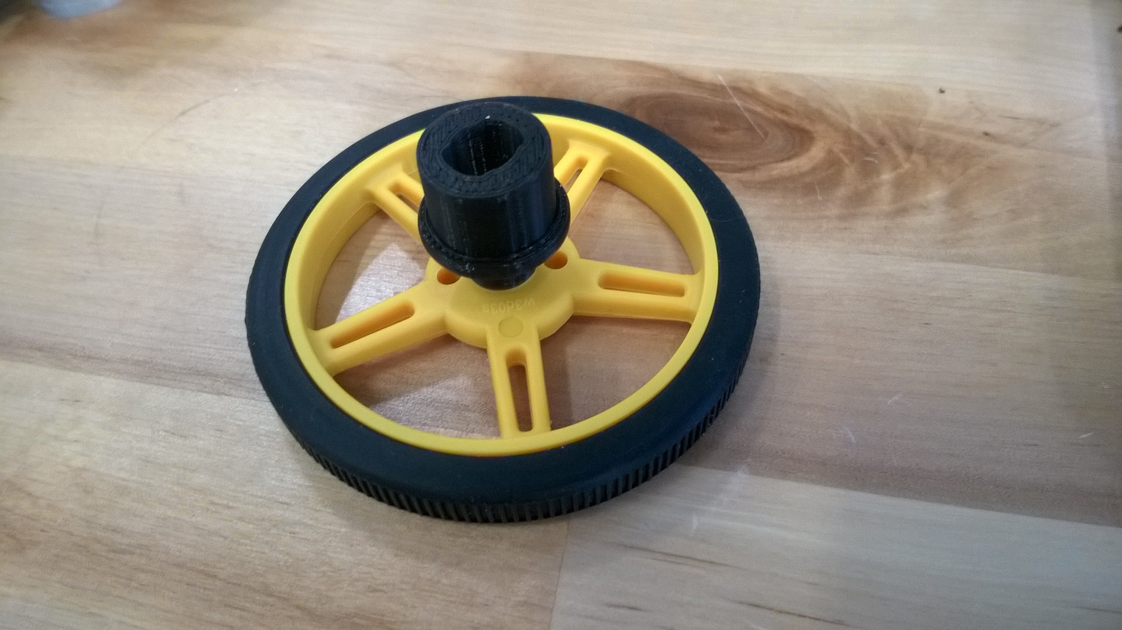

1. Laser cutting
   1. Legs
      1. Use the c_leg_t.DWG to cut the legs out of ¼ inch delrin.
      2. For the rest of the leg production, you will need to dip the legs in plastidip. For an even layer, dip the leg slowly in the plastidip and remove it slowly. Then hang it on a wire to dry. You can also use a finishing spray to ensure the coating will not peel, but this isn’t necessary.
   2. Roll bars
      1. You will need to cut two roll bars out of MDF of either 3/16 inch or ¼ inch thickness.

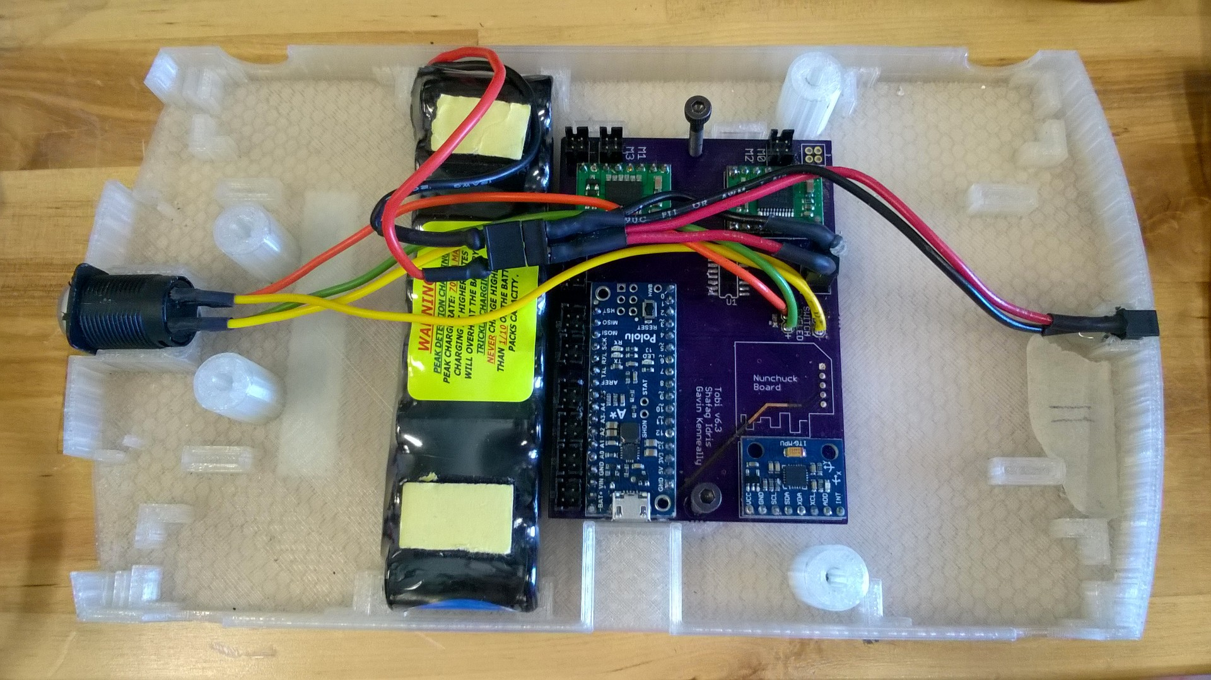

* 1. Next we will add the motors and encoders. Put a motor in each of the slots as shown below and then plug the DF11 sleeve into the connector corresponding to the appropriate leg

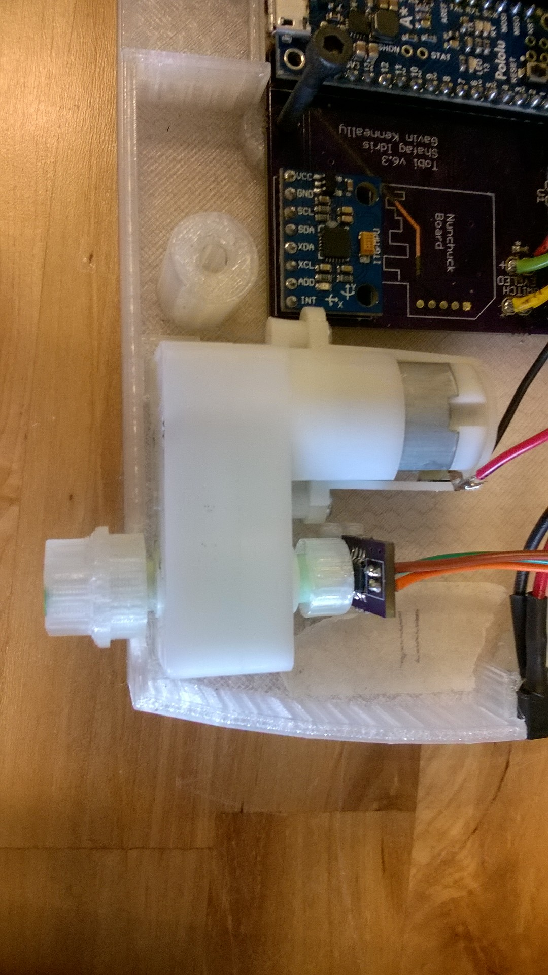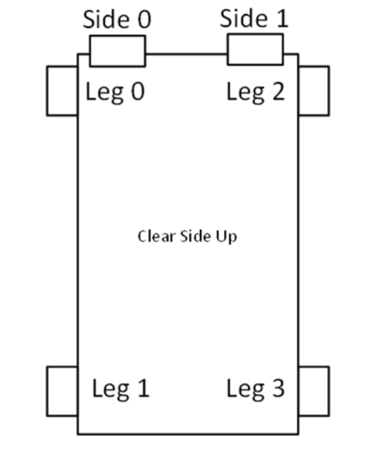

* + 1. Do the same with the encoders in the slot by the magnet shown above. The robot should now like something like this.

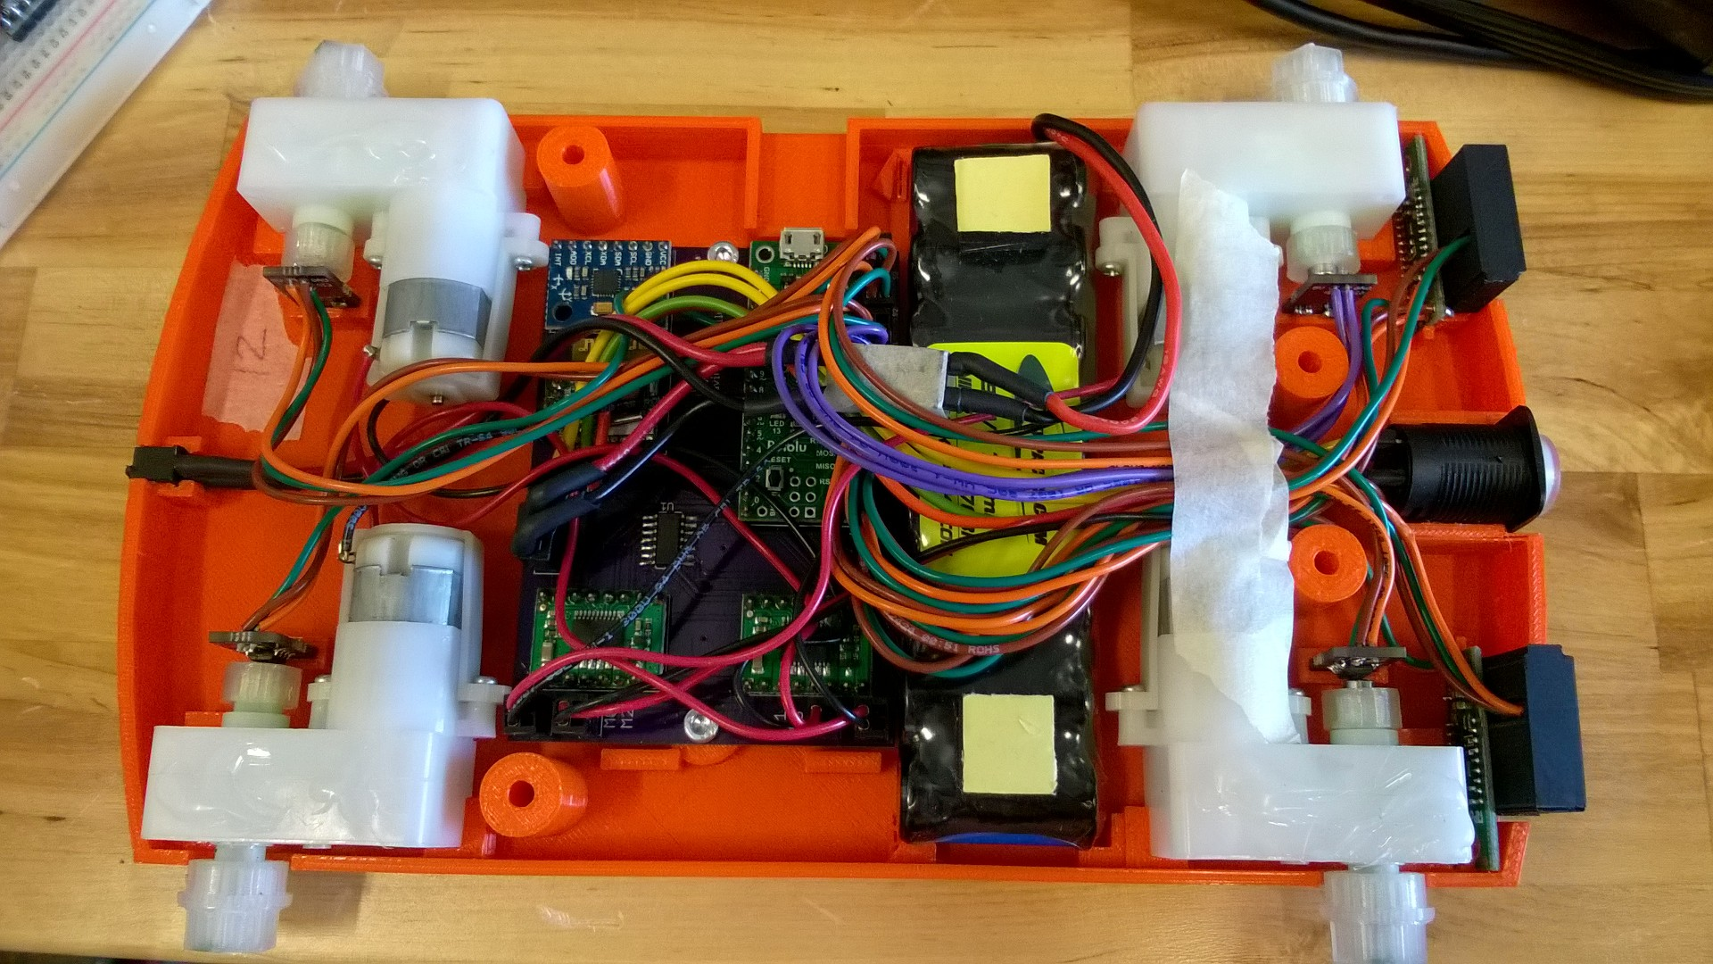

* 1. You will now want to put on the top cover. First put the breadboard on top of the wires and then place the top cover over it. Then line the bottom and top holes up and use the long screws to close the robot.

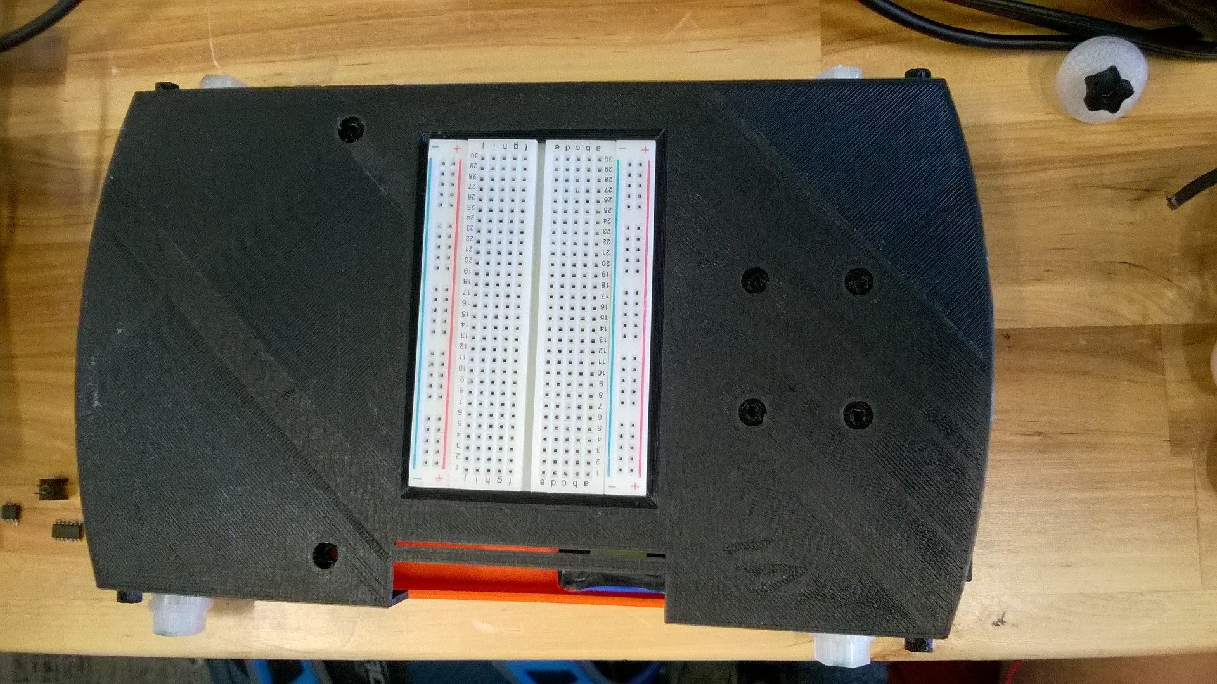

* 1. You will then want to add the s or legs (if legs make sure they will rotate in the proper direction) and the roll bar.

